1.Install artemis in ur local machine

Go to bin folder and use my below command,where myLocalBroker is the folder name.

F:\sotfwares\apache-artemis-2.19.1\bin>**artemis create /myLocalBroker**

* Once command ran , then it will create some files in that above folder , go to the folder where u installed here it is **myLocalBroker**
* Inside we have a tool called **artemis** and then execute **run** command **on this**

**Example:**

**F:\myLocalBroker\bin> artemis run**

**Use crenetials as admin and pass as admin,**

**U will find console at http://localhost:8161/console**

You can now start the broker by executing:

"F:\myLocalBroker\bin\artemis" run

Or you can setup the broker as Windows service and run it in the background:

"F:\myLocalBroker\bin\artemis-service.exe" install

"F:\myLocalBroker\bin\artemis-service.exe" start

**To stop the windows service:**

"F:\myLocalBroker\bin\artemis-service.exe" stop

**To uninstall the windows service**

"F:\myLocalBroker\bin\artemis-service.exe" uninstall

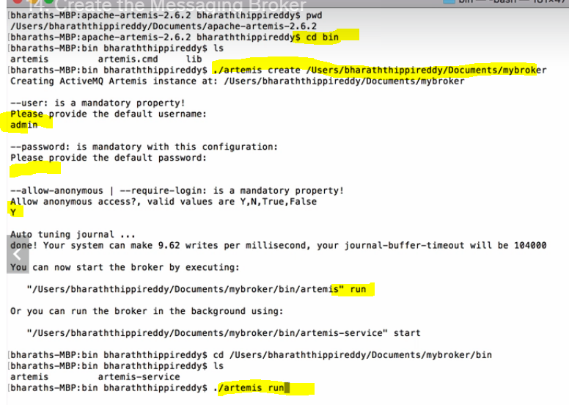

27.Prioritise messages

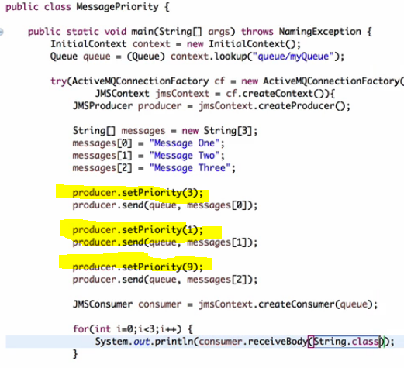s

30. Dynamically Replying to the Queue using header of the received message

While sending a message u set the header to which that consumer should respond.

Consumer, after receiving the message , he will check the header and reply to that

Real example:- in olden days, if u wanna reply to the letter, we will reply to the from address right

Same here, we have to set the header where it consist of the response queue.

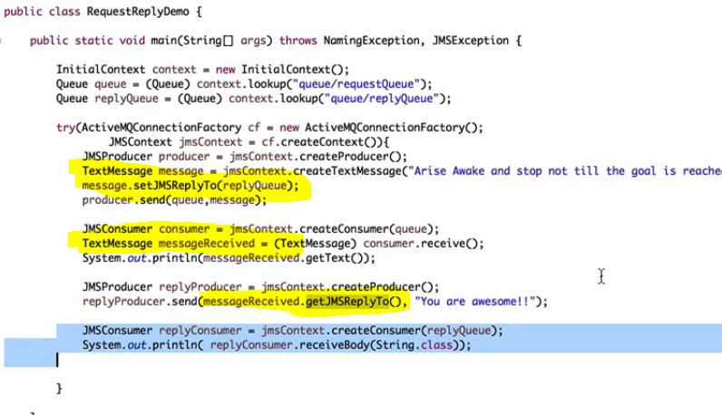

31.Replying to a temporary queue

Don’t create queue for replying , u can use temporary queues concept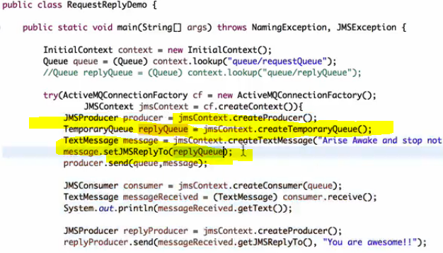

### Listening on a temporary queue

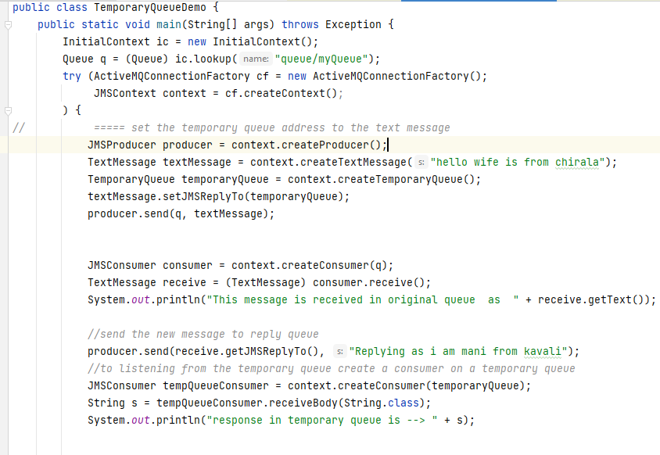

32.using co-relation id and message ID

Why?— **just to link the request and response**

See for every message , jms will provide an unique message ID

U will send a message and u will get the response and **if u want to know, the response is for which message** , then while sending the reply back , u should set the value for co-relation id field , this corelation better set same as message id u received

Note :- u cant set the message id ,but u can set the co relation id

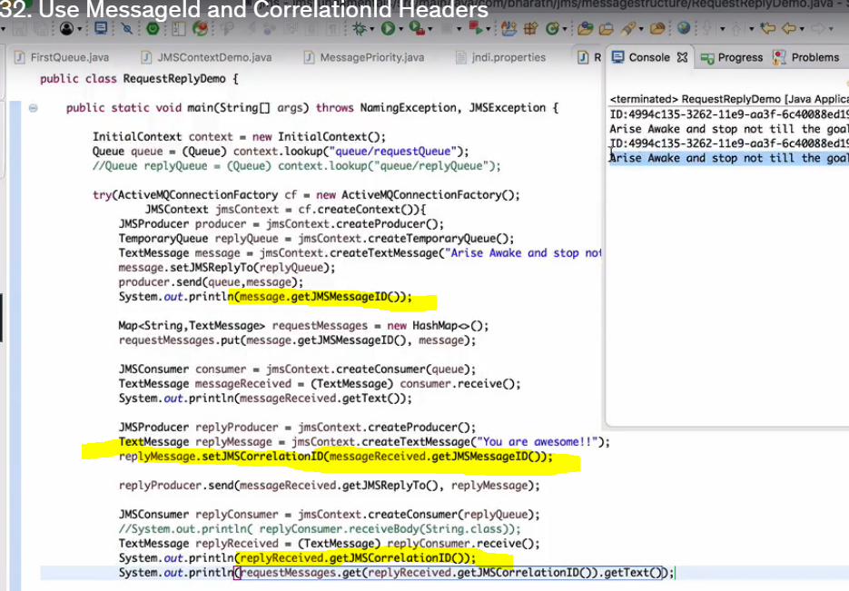

33. Set Message expiry

Once the message expired , u cant receive the message ,the expired msg will go to the expired queue.

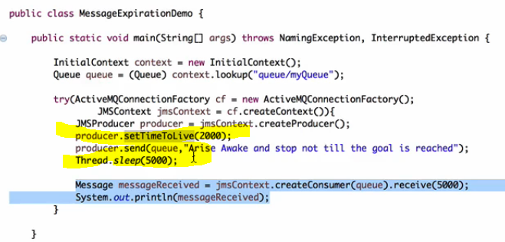

34.access expired msg

Expired messages are not lost , they were just moved to a separate queue called expiry queue, u can find the expired queue name in some xml file , and try fetching the message from there.

*To get the expired queue object , first decalre that entry in jndi.properties file*

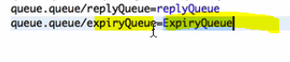

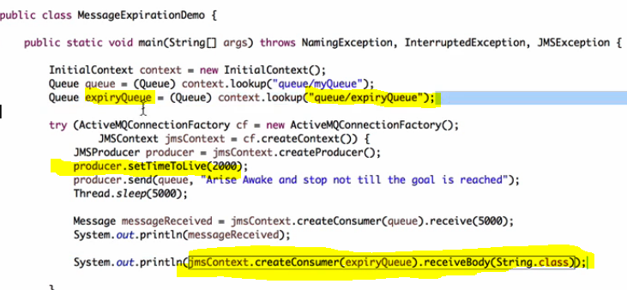

JMs Message anatomy

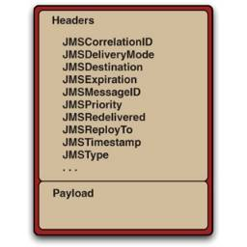

* JMS Message consist of mainly two parts **Headers** and **Pay-loads.**
* **Headers** consists of **metadata** of the message which is used by both clients and JMS Providers.
* **The Payload** consists of the actual body of the message (which can be binary or textual).
* The complexity of the JMS Message lies in headers.

35.Delay Message delivery

If u set this it will deliver after some time

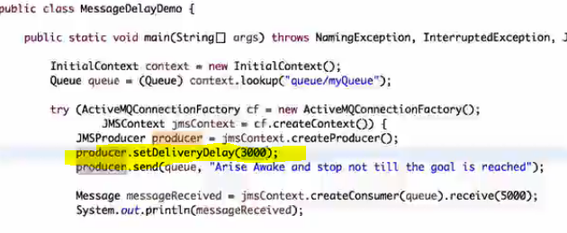

36.Set custom properties

0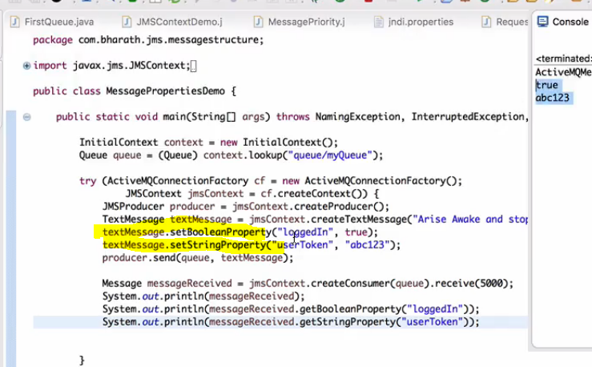

37.Message Types

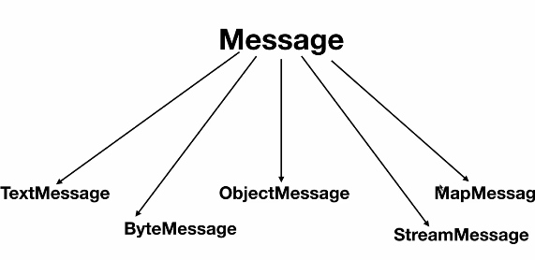

38.Message types in action

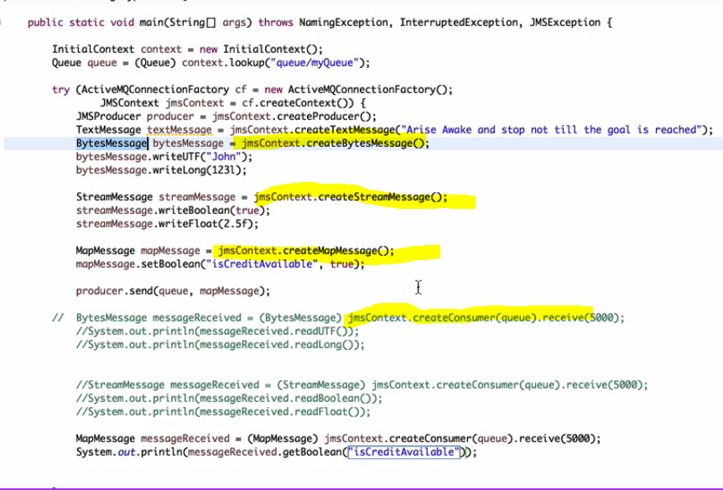

39.sending object to Queue

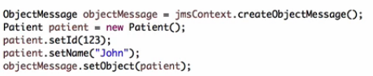

The advantage with above approach is , u can set the properties to the class ObjectMessage like replyTo …, actualy u can directly also send any object like below

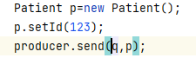

To receive – the below statement will wait for 5 seconds,if no msg it will exit

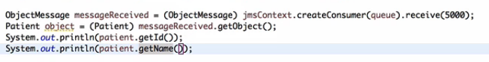

40. When to use P2P

In p2p , once a message is read , then that is lost

Use this when we have only 1 consumer.if 2 apps wants same data then go for pub-sub

We can increase the performance by increasing the numn of queues.

In p2p we have concept of QueueBrowser

Real use case :-

1)Amazon payment- when we made payment in amazon, we might be using a p2p model, the payment status success or failure will be kept in the response queue, reply queue and response queue may be different.

2) IRCTC ticket booking- generally it will communicate with many other,. The actual booking could be another service and it may reply via another response queue.

### **41.why asynchronous processing**

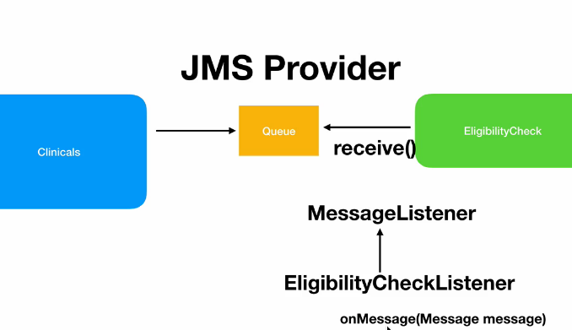

Problem is below is a blocking call.

Context.createConsumer(queue).receive(5000);

Whereas in async processing , we will be having a message listener, that will automatically be fired once msg arrived

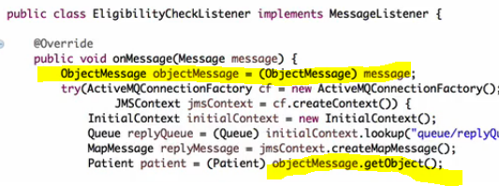

After creating consumer , its mandatory to attach listener

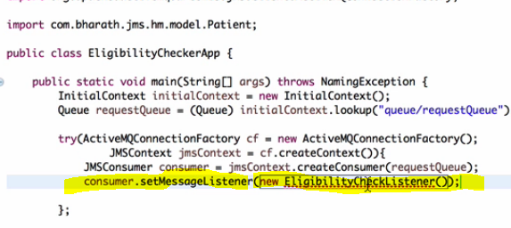

* **point-to-point model**: **Queues** are used as a destination in the point-to-point model. You can send and receive messages synchronously or asynchronously. **MessageConsumer.receive()** method is used to send messages synchronously to a consumer through queues.
* **MessageConsumer.setMessageListener()** method is used to receive messages asynchronously to a consumer through queues.
* At a time, only one consumer will be able to receive a message from the queue.
* In the above diagram, at a time only one message sent by the producer is sent to the queue, and the queue will send the message to only one consumer at a single time.
* JMS Provider uses **Round-robin** style to send a message across all the consumers.

42.Pub-sub model

When u want to tell the same information to many subscribers then go with topics

Put the message in topics,

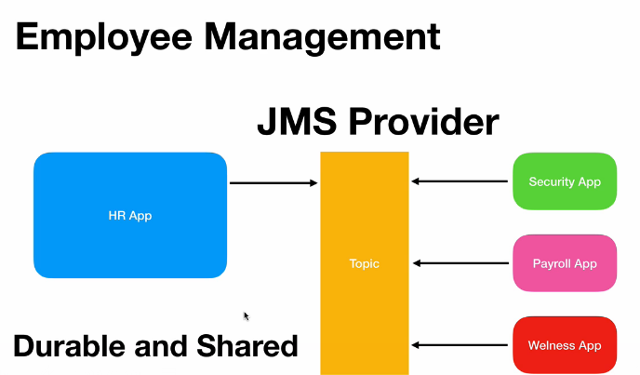

### Pushing to a topic

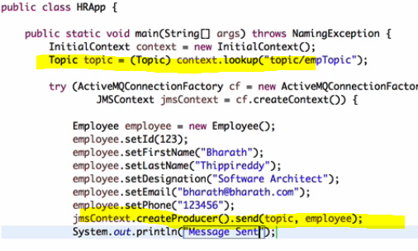

Consuming from a topic

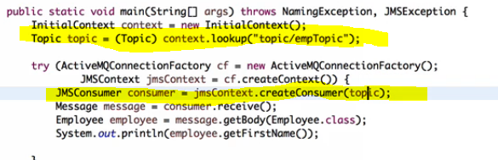

Durable subscriptions

When producer kept the message into the queue, if 1 among the 3 consumers went down, the message will still be preserved , once that consumer came online the message will be delivered

Once all the durable subscribers read the message , then only the message will be removed

